
DEDAN KIMATHI UNIVERSITY OF TECHNOLOGY

University Examinations 2015/2016

SECOND YEAR FIRST SEMESTER EXAMINATON FOR THE DEGREE OF BACHELOR OF SCIENCE IN MECHATRONIC ENGINEERING

EMT 2201 PLANAR MECHANISMS I

DATE:9TH SEPTEMBER 2015 TIME: 8.30AM – 10.30AM

INSTRUCTIONS
- This paper contains FIVE questions. Attempt ANY THREE questions. All questions carry equal marks.
- Take g = 9.81 m/s² where necessary.
3. All symbols have usual meaning unless otherwise stated.

QUESTION 1 (20 Marks)

(a) Differentiate between the following two terms as used in mechanics.
(i) Machines and mechanisms
(ii) Kinematic pair and kinematic chain
(3 Marks)
(b) What do you understand bykinematic analysis of mechanisms?What are the specific problems in kinematic analysis?
(2 Marks)
(c) Fig. Q. 1 (c) shows a quick-return shaper mechanism driven by crank AB. Given the lengths AB = 0.20m, AO = 0.40m, CD = 0.70m and CE = 0.30m and that at the instant shown the input angle 45⁰,
(i) Determine the distance of point B from point D using the vector loop method.
(ii) Determine the position of all the joints analytically.
(15 Marks)

QUESTION 2 (20 Marks)

(a) (i) What do you understand by kinematic inversion. When is kinematic inversion employed in the study mechanisms?
(ii) Define a higher pair. With the aid of simple sketches, illustrate any two higher pairs.
(5 Marks)
(b) The slider-crank mechanism shown in Fig. Q. 2(b) has the dimensions: AB = 0.5 m and BC = 1 m. The driver link 1 makes an angle of 45⁰with the horizontal axis. Find the positions of the joints and the angle the connecting rod is making with the horizontal axis using the absolute cartsian method.
(5 Marks)
(c) (i) Define the termgeneral plane motion and give four examples. What do understand by instantaneous centre as used in mechanisms?
(ii) The crank of an engine mechanism has a length of 35mm and the connecting rod is 124 mm. Calculate the velocity of the piston when the engine rotates at 2500 rpm and the angle between the crank and the line of stroke is 45⁰. Also find the angular velocity of the connecting rod. Use the instantaneous center method.
(10 Marks)
QUESTION 3 (20 Marks)

(a) (i) Perform a complete velocity analysis of the linkage shown in Fig. Q. 3 (a) for a constant input speed of crank 2 of 18 rad/s. OA = 0.203m and OB = 0.254m. The block 4 is pivoted at B and the link 3 slides through it.
(ii) What is the acceleration of the point A at the instant shown?
(9 Marks)
(b) In the mechanism shown in Fig. Q. 3 (b), the crank AB revolves anticlockwise at 16 rad/s and the point D is constrained to move vertically downwards at 2m/s. Draw the velocity diagram and determine:
(i) the rubbing speed at E if the pin diameter is 30mm.
(ii) the velocity of F.
The link CE= 450mm and is horizontal in the position shown.
(11 Marks)

QUESTION 4(20 Marks)

(a) (i) Give the formulas for tangential and normal components of acceleration.
(ii) State Coriolis theorem as used in acceleration analysis of mechanisms. What is the magnitude and direction of the Coriolis component?
(4 Marks)
(b) The end A of a bar AB shown in Fig. Q. 4 (b) is constrained to move along the vertical path AD and the bar passes through a swivel bearing pivoted at C. Draw the velocity and acceleration diagrams for the given configuration when A has a velocity 3m/s towards D and an acceleration of 25m/s² in the opposite direction. Hence determine;
(i) the velocity and acceleration of sliding of the bar through the swivel.
(ii) the angular velocity and angular acceleration of AB.
(16 Marks)

QUESTION 5(20 Marks)

(a) (i) What do you understand by a conservative system? Show that in a conservative linkage the mechanical advantage is given by;

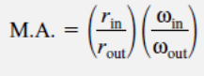
(ii) What is the importance of the transmission angle in a planar four-bar linkage?
For a four-bar planar linkage, derive an expression showing the correlation between mechanical advantage and the transmission angle in terms of the input and output radii, the link lengths and a suitable angle between links.
(10 Marks)
(b) Fig. Q. 5 (b) shows a sketch of slider-crank mechanism that is to be analyzed to obtain velocity and acceleration analytically.
(i) Explain why loop equations will be preferred.
(ii) Name the four inversions of the mechanism. (4 Marks)
(c) (i) In modeling of real four-bar linkages where the weights of the links are taken into consideration, list any three assumptions and/or restrictions imposed for getting solution.
(ii) Explain why we still have to carry out computer modeling and simulations on relatively simple four-bar mechanisms.
(6 Marks)

EMT 2201 FIGURES

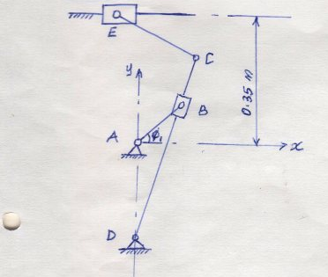  Fig. Q. 1 (c) | 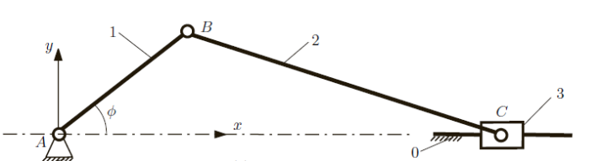  Fig. Q. 2(b)
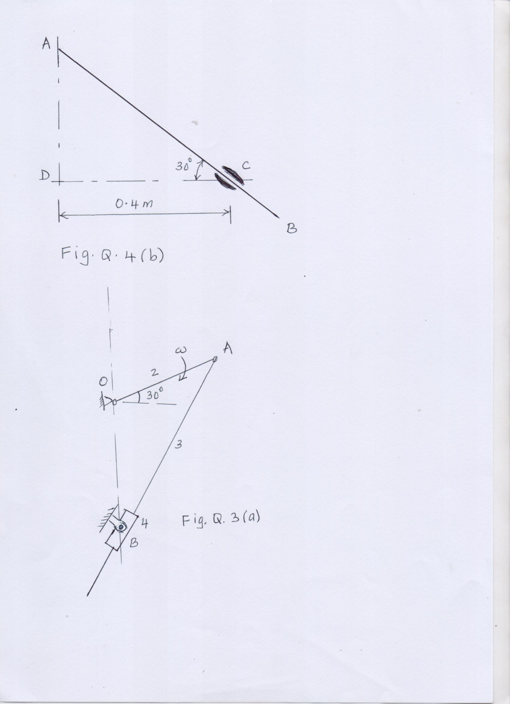 | 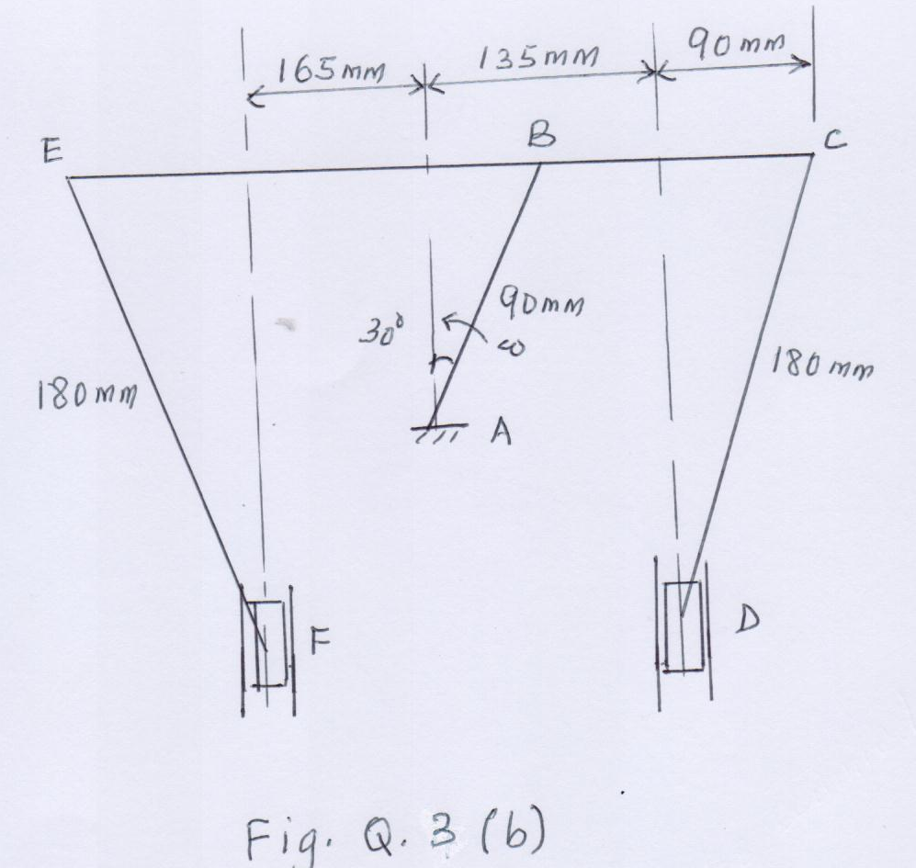

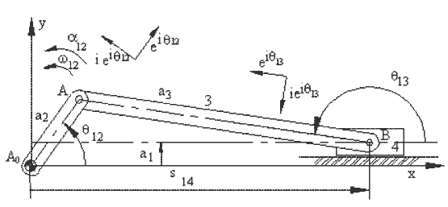

Fig. Q. 5 (b)

